BENEFIT RAFFLE

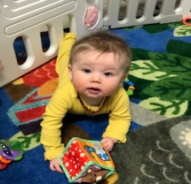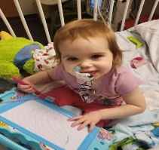

2-YEAR-OLD SARAH ROBERTS DIAGNOSED

WITH STOMACH CANCER

BABY MCLAREN SPEED LOST DADDY TO COVID

BABY HUDSON CRUNKLETON SEVERE HEALTH ISSUES

**TICKETS $25.00 EACH**

DRAWING ON MAY 27, 2022

FOUNDATION ACADEMY, 120 COMMERCE PKWY, CORNELIA GA

**ONE WINNER TAKES ALL**

**AWESOME PRIZES**

YETI COOLER & UTILITY CART FILLED WITH TONS OF GIFT CARDS, GOODIES & GIFT BASKET’S.

**A SPECIAL THANK YOU TO OUR COMMUNITY SPONSORS.**

**CHICK-FIL-A BIGG DADDY’S LINDSEY NASH @ NASH & CO. WICKED CANDLE CO.**

**ERIN LONDON BLUE WILLOW FLORAL & GIFT’S AURORA FALLS**

**LAURA & JOSH ANDERSON MIDTOWN GRILL ERWIN RUSH**

**THE COMFY CORNER SUGARTOPIA ACE HARDWARE INITIALS INC.**

**THE GATHERING BOX CASSIE CHEEK @ SALON 447 TIMS PHARMACY**

**BROWNIES BY FAITH FARM & LAVISH CHICAGO PIZZA EL PATRON**

**BOB & TEDS TROPHY SHOP CANDY RAY DILL @ NASH & CO CREATIVE EDGE DESIGNS, LLC**

**SCRAP SCAVEY DESIGNS JACOB DARLING @ UNICOI OUTFITTERS ALL ABOUT MONROE**

**CANDACE NEWSOM @ ELEVATED HAIR LOUNGE**

**SEVERAL ANONYMOUS COMMUNITY SPONSORS**