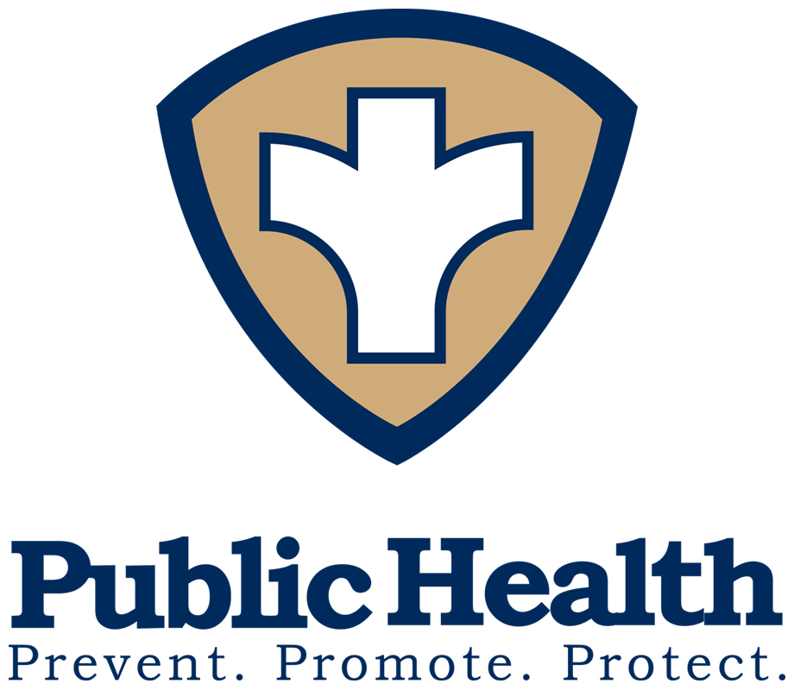
District 2 Public Health
Pamela Logan, M.D., M.P.H., M.A., Health Director
1280 Athens Street • Gainesville, Georgia 30507
PH: 770-535-5743 • FAX: 770-535-5958 • www.phdistrict2.org

Banks, Dawson, Forsyth, Franklin, Habersham, Hall, Hart, Lumpkin, Rabun, Stephens, Towns, Union and White Counties

FOR IMMEDIATE RELEASE CONTACT: Dave Palmer, Public Information Officer

DATE: March 16, 2020 PH: 770-531-5679 • FAX: 770-535-5958
Dave.palmer@dph.ga.gov

District 2 Public Health sees first confirmed cases of covid-19

GAINESVILLE, GA – The Georgia Department of Public Health has confirmed three positive cases of Coronavirus Disease 2019 (COVID-19) in District 2. District Public Health epidemiology is working to identify and notify any close contacts who may have been exposed to COVID-19.

Two cases were reported in Hall County on Sunday, March 15. A third case was reported in Forsyth County also on Sunday.
Elderly people and individuals with chronic medical conditions may have increased risk. The best prevention measures for any respiratory virus are:
- Wash your hands often with soap and warm water for at least 20 seconds. If soap and water are not available, use hand sanitizer containing at least 60% alcohol.
- Avoid touching your eyes, nose and mouth.
- Avoid close contact with people who are sick. Maintain at least 6 feet of space from anyone who appears ill.
- Stay home when you are sick.
- Cover your cough or sneeze with a tissue, then throw the tissue in the trash.
- Clean and disinfect frequently touched objects and surfaces.
If you develop fever with cough and shortness of breath, or if you have had contact with someone who is suspected to have COVID-19, stay home and call your health care provider. Be sure to call before going to a doctor’s office, emergency room, or urgent care center and tell them about your symptoms.
For updated information on COVID-19, visit dph.georgia.gov/novelcoronavirus or https://www.cdc.gov/coronavirus/2019-nCoV/index.html

END

