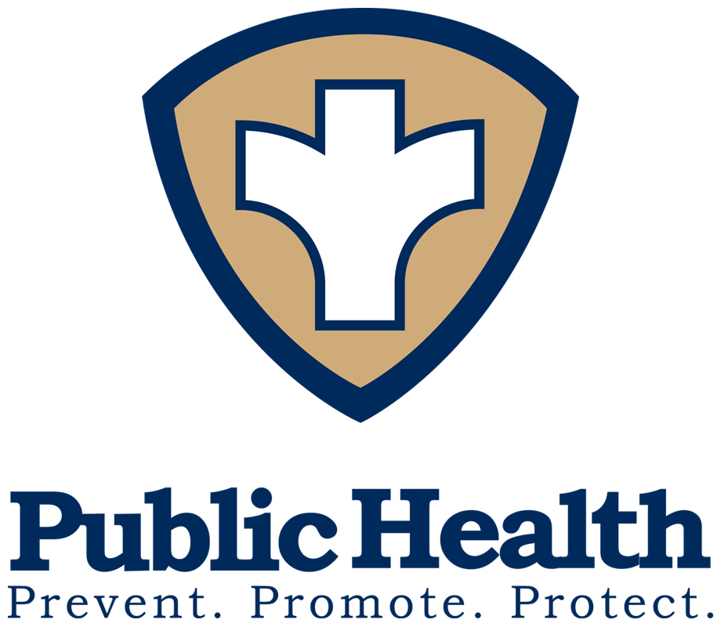
District 2 Public Health
Pamela Logan, M.D., M.P.H., M.A., Health Director
1280 Athens Street • Gainesville, Georgia 30507
PH: 770-535-5743 • FAX: 770-535-5958 • www.phdistrict2.org

Banks, Dawson, Forsyth, Franklin, Habersham, Hall, Hart, Lumpkin, Rabun, Stephens, Towns, Union and White Counties

FOR IMMEDIATE RELEASE CONTACT: Dave Palmer, Public Information Officer

DATE: March 18, 2020 PH: 770-531-5679 • FAX: 770-535-5958
Dave.palmer@dph.ga.gov

District 2 Public Health has additional confirmed cases of covid-19

GAINESVILLE, GA – The Georgia Department of Public Health has confirmed three more positive cases of Coronavirus Disease 2019 (COVID-19) in District 2. One case is in Forsyth County and two cases are in Hall County.

This brings the total cases to five cases in District 2. Two cases total in Forsyth County and three cases total in Hall County.
Elderly people and individuals with chronic medical conditions may have increased risk. The best prevention measures for any respiratory virus are:
- Wash your hands often with soap and warm water for at least 20 seconds. If soap and water are not available, use hand sanitizer containing at least 60% alcohol.
- Avoid touching your eyes, nose and mouth.
- Avoid close contact with people who are sick. Maintain at least 6 feet of space from anyone who appears ill.
- Stay home when you are sick.
- Cover your cough or sneeze with a tissue, then throw the tissue in the trash.
- Clean and disinfect frequently touched objects and surfaces.
If you develop fever with cough and shortness of breath, or if you have had contact with someone who is suspected to have COVID-19, stay home and call your health care provider. Be sure to call before going to a doctor’s office, emergency room, or urgent care center and tell them about your symptoms.
For updated information on COVID-19, visit dph.georgia.gov/novelcoronavirus or https://www.cdc.gov/coronavirus/2019-nCoV/index.html

END

