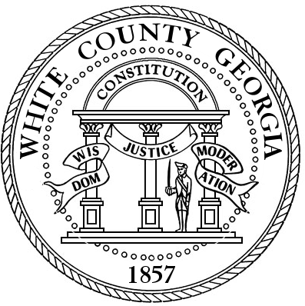Cindy Cannon
White County Tax Commissioner Office
113 North Brooks Street
Cleveland, Georgia 30528
(706) 865-2225
Fax (706) 219-0078

March 19, 2020

Press Release

White County Tax Commissioners Office lobby area will be closed to the public effective Monday March 23, 2020. Our Drive-Thru will remain open.

Effective Monday, March 23, 2020 and for at least the following two (2) weeks (through Friday, April 3, 2020) The White County Tax Commissioners office will begin servicing customers through Drive Thru only. Employees will be available by phone, email, and internet to continue providing customer service and assistance to our taxpayers.

For the taxpayers who can, I encourage them to utilize our many online options which may be found on the White County Tax Commissioner page located at www.whitecounty.net . Vehicle registration renewals and Property tax payments may be handled online. Please keep in mind we also honor postal service postmark for mail payments.

If you have questions or concerns regarding your individual situation – please call the White County Tax Commissioners office at 706-865-2225 or by sending an e-mail to our office wctc@whitecounty.net

Cindy Cannon
White County Tax Commissioner

